Name : Saurabh Sanjay Jadhav.

Topic : IAM role for EC2 instance.

Assignment no. : 16

1. Create a IAM role. Select aws service for which role needs to created “EC2 instance”

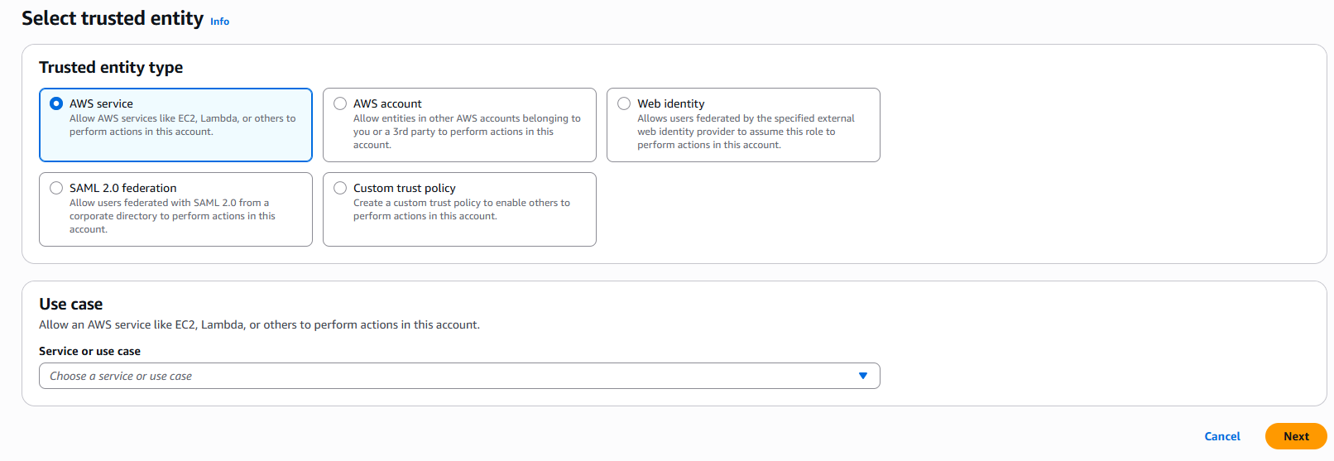

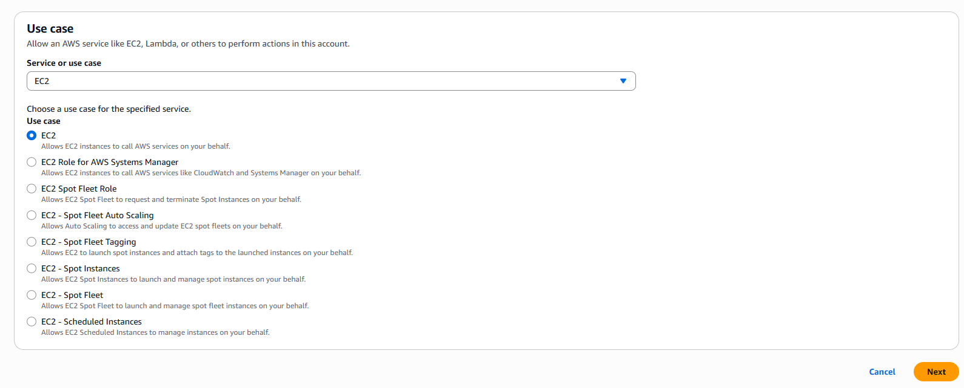

1. Select permission as “administrator access”.

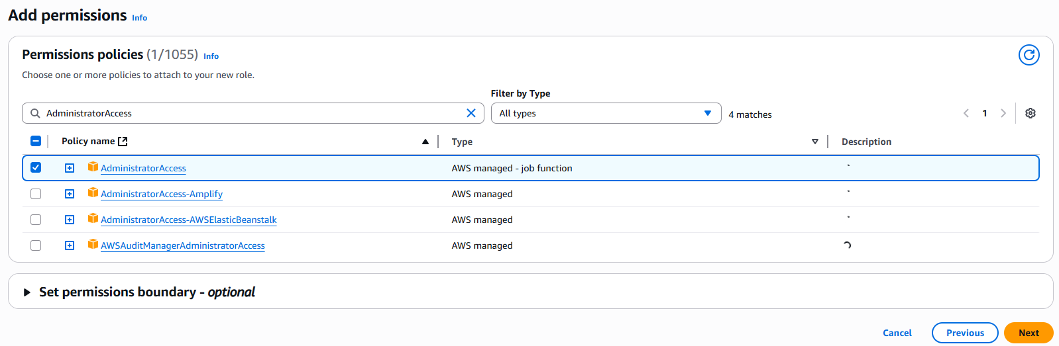

1. Provide role name & check the summary of role. Click on create role.

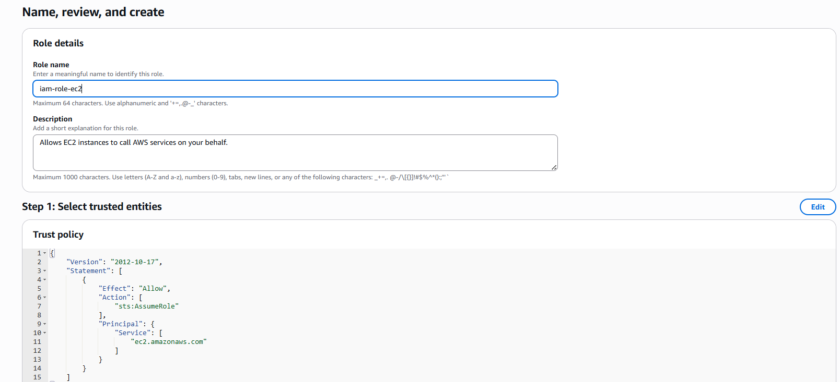

1. Create EC2 instance with role. Do configurations in advance settings.

1. Create another EC2 instance as default.
2. EC2 instance without role cannot run aws commands.

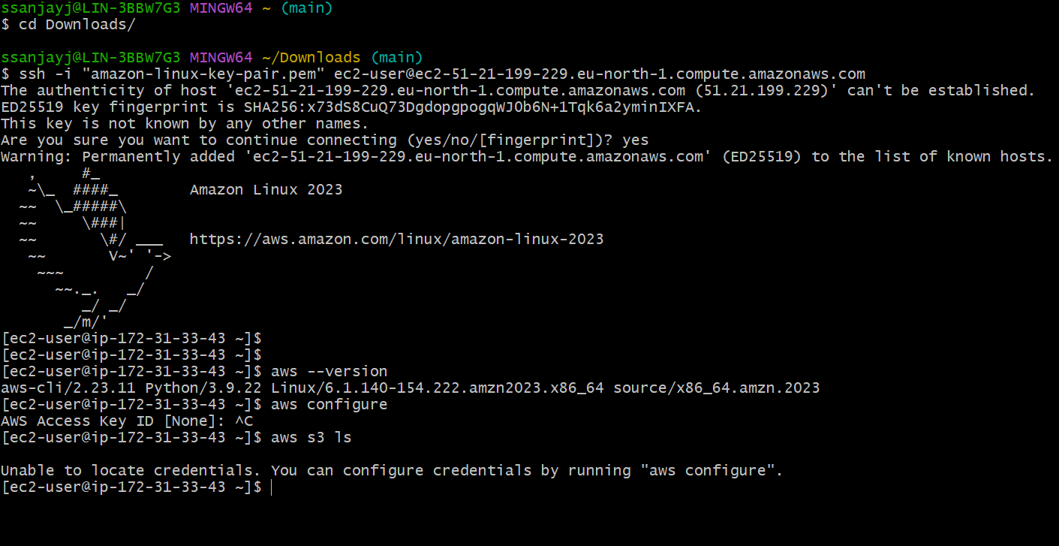

1. EC2 instance with role as “administrative acces” with give requires permissions to create aws resources.

Create a s3 bucket.

Upload a file in the bucket.

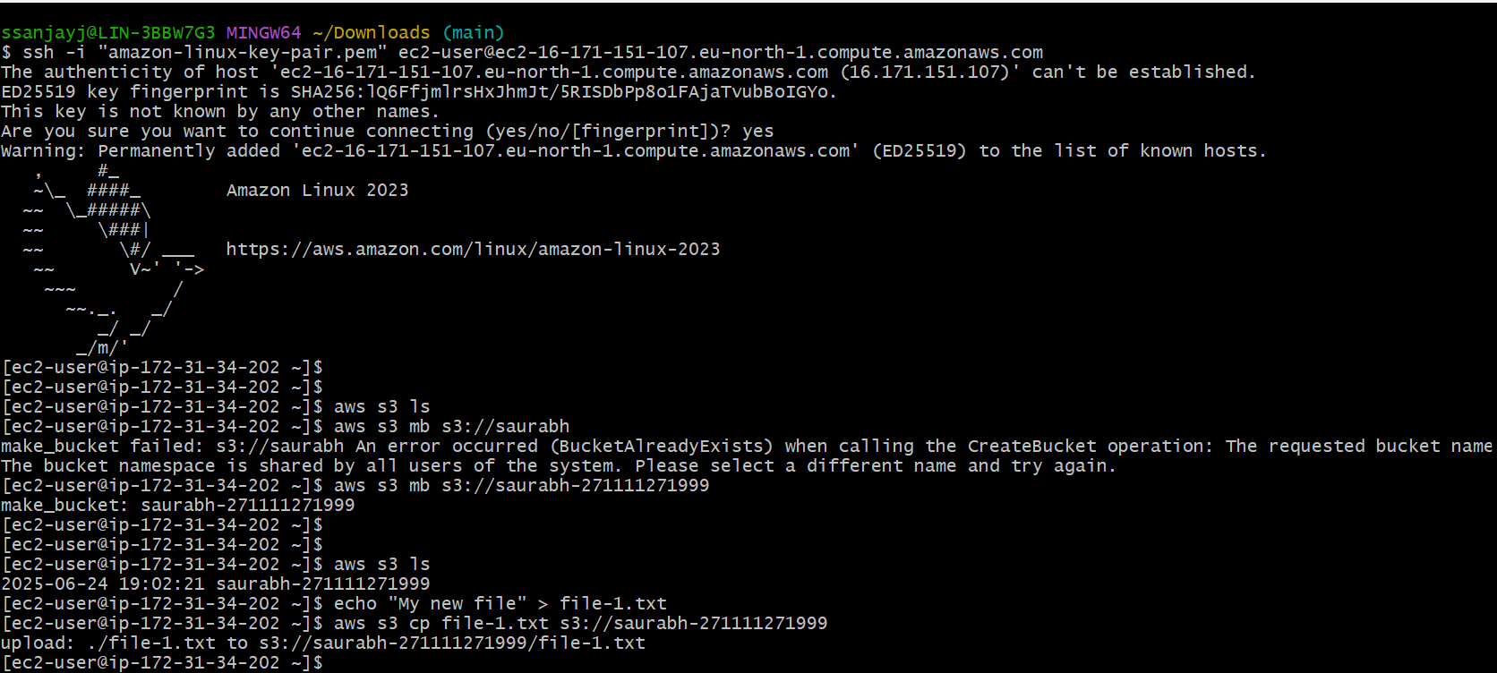

List the files in s3 bucket.

Delete the file from bucket.

